МИНИСТЕРСТВО ОБРАЗОВАНИЯ И НАУКИ РФ
ГОСУДАРСТВЕННОЕ БЮДЖЕТНОЕ ОБЩЕОБРАЗОВАТЕЛЬНОЕ УЧРЕЖДЕНИЕ
БРЯНСКИЙ ГОРОДСКОЙ ЛИЦЕЙ №1
ИМЕНИ А.С.ПУШКИНА

241050, Брянск, ул. Советская , дом 98
Телефоны (4 832) 72-21-42, 72-21-28, 72-21-15 Факс: (4832) 72-21-28 E-mail: lyc1@mail.ru
ОКПО 32086049, ОГРН 1023280750041, ИНН/КПП 3234029032 / 320101001 , ЛИЦЕНЗИЯ 32 № 000908

Партизанское движение на Брянщине
в годы Великой Отечественной войны

Научно-исследовательский проект по краеведению
На английском языке

Авторы: учащиеся ГБОУ «Брянский городской лицей №1 имени А.С. Пушкина»
члены английского клуба LINGUA

Научный руководитель:
Шмакова Ольга Ивановна
учитель английского языка
I квалификационной категории,
Почётный работник
общего образования Российской Федерации

Брянск 2020 год

Паспорт исследовательского проекта

- Тема проекта: Исследование по краеведению. Партизанское движение на Брянщине в годы Великой Отечественной войны.
- Цели проекта: исследовать исторические материалы о партизанском движении на Брянщине в годы Великой Отечественной войны, собрать материал для проведения виртуальных экскурсий по партизанским местам Брянщины в годы Великой Отечественной войны.
- Задачи проекта:
- Воспитывать дух патриотизма и гордость за свою Родину.
- Сохранять и приумножать историческое и культурное наследие прошлых поколений.
- Беречь памятники истории и культуры.
- Способствовать формированию познавательного интереса к процессу обучения.
- Развивать умение самостоятельно находить и грамотно оформлять нужную информацию.
- Авторы проекта: учащиеся ГБОУ «Брянский городской лицей №1имени А.С.Пушкина» члены английского клуба LINGUA.
- Количество участников: 10 социально-экономический №1 – 7 человек, 10 социально-экономический №2 – 5 человек, 10 физико-математический – 3 человека, 10 медицинский №2 – 1 человек.
- Руководитель проекта: Шмакова Ольга Ивановна учитель английского языка Брянского городского лицея №1 имени А.С. Пушкина, Почётный работник общего образования Российской Федерации.
- Тип проекта:
- По доминирующей деятельности: информационно-поисковый;
- По предметно-содержательной области: краеведческий;
- По количеству участников: групповой;
- По широте охвата содержания: интегрированный;
- По времени проведения исследования: продолжительный (7 месяцев).
- Образовательная область: английский язык.
- Используемые методы: экскурсии по партизанским местам Брянщины, посещения экспозиций Брянского краеведческого музея и работа с архивными материалами музея, работа в иностранном отделе Брянской областной библиотеки, использование ресурсов сети Интернет.
10.Форма представления результатов: виртуальная экскурсия, презентации, буклеты, стенгазеты, альбом.
11. Источники информации: энциклопедии, справочники, архивные материалы Брянского краеведческого музея, русско-английские словари, материалы сети Интернет, материалы иностранного отдела Брянской областной библиотеки.

The Underground and Partisan Struggle in Bryansk Region during the Period of

1941-1943
The hardest testament in history for the Bryansk population alongside with all Soviet people was the Great Patriotic war. Our fathers and grandfathers covered themselves with undying glory in its battlefields.
The aim of fascist Germany in the invasion of the Soviet Union was not only to occupy the territory of the country and rob its riches but also to exterminate physically most of the population and make the rest the slavers of the German capitalists and landlords. This criminal idea of the German fascists found its fulfillment in a program worked out long before the war against the Soviet Union. Already in December 1940 Hitler declared openly: "If we want to create our Great German Empire, we must, first of all, drive out Slavonic peoples - the Russians, the Ukrainians, the Byelorussians".
Already in the first days of July, 1941 the German aircraft began bombing Bryansk. The life of the city was subordinated to the demands of war time. The plants turned to exclusively military production, the call-up for military service was underway, the triple defensive line of 100 kilometers was being constructed. At the end of June the withdrawal of the industrial enterprises, offices and population started. The city was preparing to struggle against the enemy. Two partisan detachments and nine underground groups were formed.
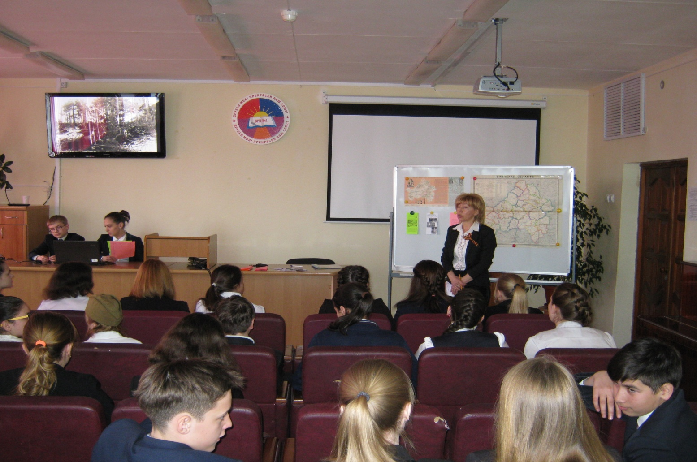

The Bryansk front troops detained the invaders on their way to Moscow for one and a half month, but the forces were unequal and in October our troops had to leave the city. The occupation lasted 708 days. It was the time of terror for the population. Arrests, executions, famine, sending people to Germany against their will – that was the meaning of fascist “new order” for our city.
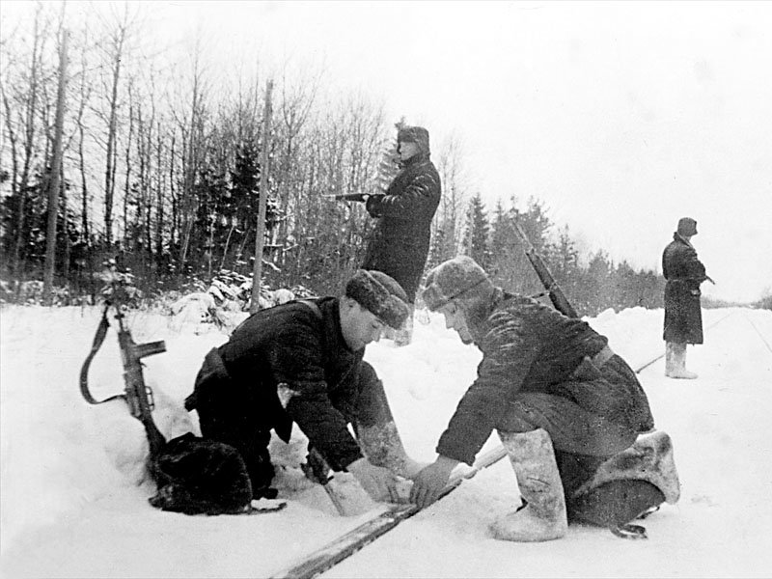
There were more than 60 000 partisans fighting against the enemy in the forests surrounding Bryansk. Tens of blown-up bridges, hundreds of derailed trains, tens of thousands of killed enemy soldiers – that is their contribution to the Victory.
Motherland appreciated highly the feats of arms perpetrated by the citizens of Bryansk: 22 of them were awarded the high titles of the Heroes of the Soviet Union, thousands of soldiers and partisans were awarded orders and medals.
Bryansk was liberated by the Soviet troops and the partisans on the 17th of September, 1943. The city was practically erased from the earth. The industrial enterprises, railway junctions, bridges, public buildings, more than three quarters (3/4) of living houses were destroyed.

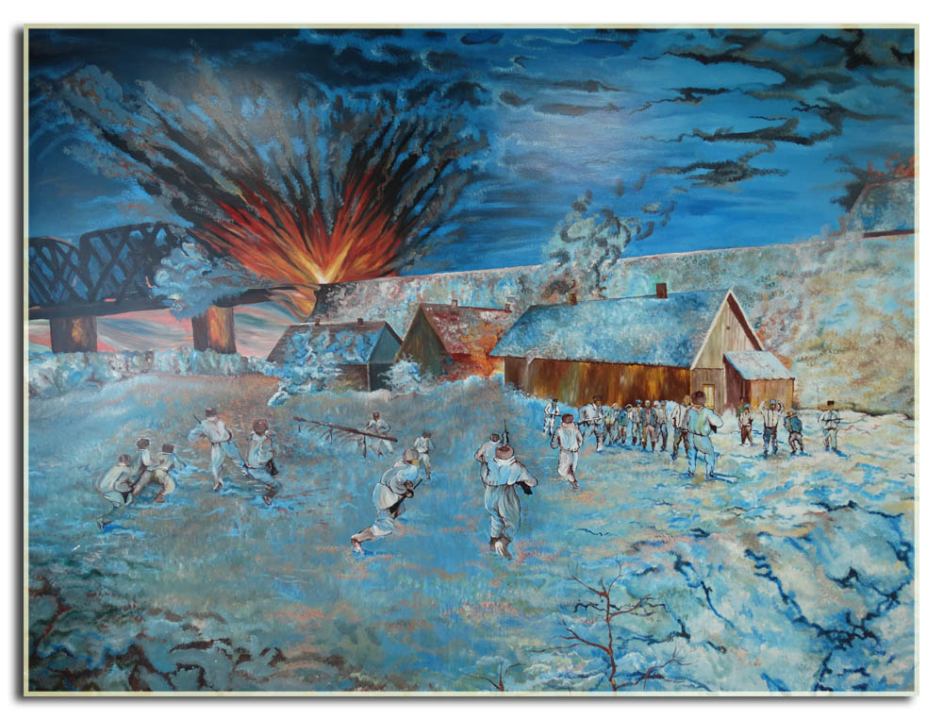
In our Bryansk region there is a unique museum of partisan glory. The museum is located on a meadow by the river Snezhet. The composition of the memorial complex includes a marble memory wall with the names of the dead partisans on bronze plates and symbolic bronze sculptures. This exhibition of the museum was made on a high artistic level in 1994. It reflects the main stages of the partisan movement in the Bryansk region in 1941 - 1943. It represents personal things, awards, weapon of partisans. Voiced diorama Explosion of the Blue Bridge depicts an episode of the most famous partisan operation.

In the Bryansk region, Soviet partisans controlled large areas behind the German lines. In the summer of 1942 they effectively held more than 14,000 square kilometers with a population of over 200,000 people. Soviet partisans in the region were led by Oleksiy Fedorov, Alexander Saburov and others and numbered over 60,000 men. Bryansk region had a significant partisan activity during the occupation period. In the Oryol and Smolensk regions partisans were led by Dmitry Medvedev.
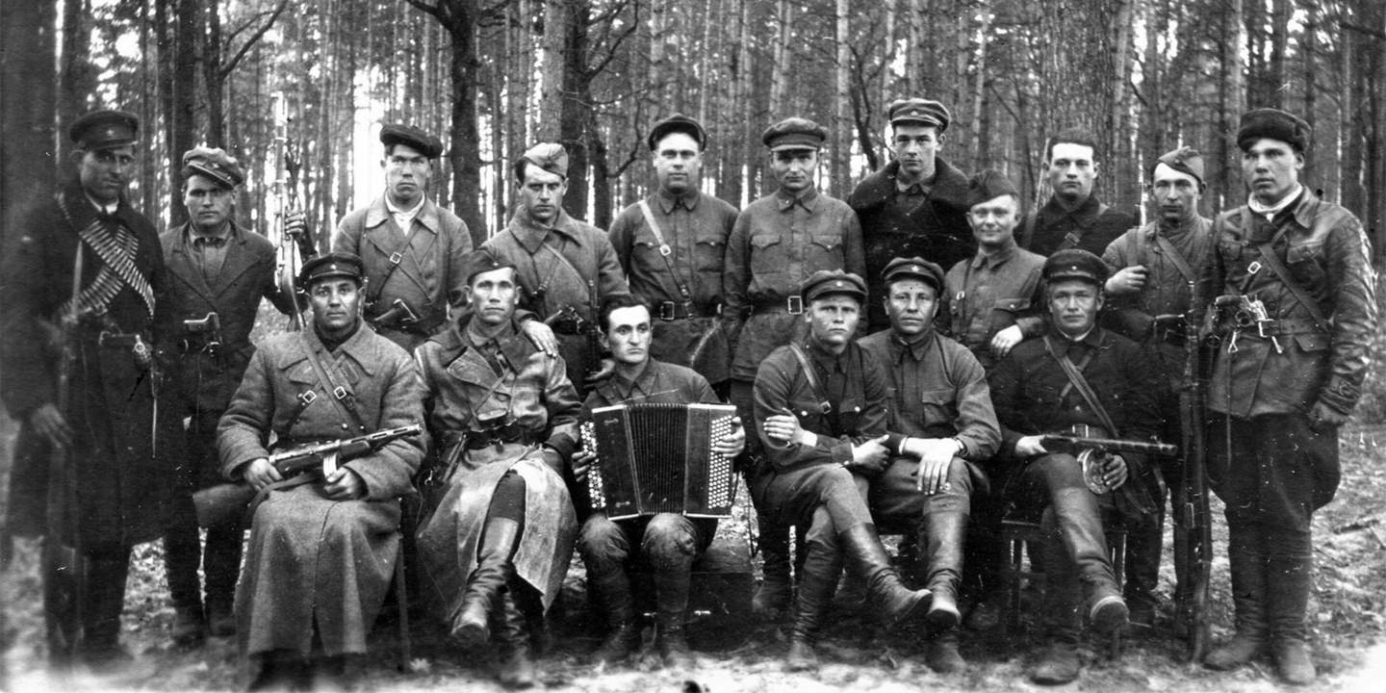

It has to be said that Bryansk is often called a city of Partisan Glory. Bryansk became widely known as the center of heroic fight of the partisans against the German fascist invaders. 60 000 people took part in the struggle during the Great Patriotic War. Hundreds of derailed trains and blown-up bridges, thousands of killed enemy soldiers – that was their contribution to the Victory.

A number of monuments and memorials remind Bryansk people and tourists of the city’s glorious history. There are many monuments symbolizing the feats of Bryansk warriors in the times of the Great Patriotic war. In 1979 Bryansk was awarded the Order of the October Revolution. And in 2010 Bryansk has received a rank of the City of Military Glory.

Partisan detachments and underground organizations were formed in the occupied territories of the Bryansk region. The Bryansk region became one of the main hotbeds of partisan movement. Forests gave shelter to the partisans. The partisans fought in the terrain that the Germans found impossible to control. They were engaged in the classic guerilla activity – hit and run tactics. A lot of railway bridges and locomotives were destroyed by partisans. One of the most important operations was the destruction of the Blue bridge on the 8th of March in 1943.

Our Bryansk Region during the years of the Great Patriotic War

Our Bryansk region was liberated from the fascist invaders on the 17 of September in 1943. The 17 of September is a special day. It’s a wonderful holiday different from all other holidays. It’s a national holiday and at the same time a very personal one. Young generation knows about the Great Patriotic War only from books and films. But it is hard to believe that your hearts are not exited when you meet with war veterans. And you cannot find a family where those who defeated their lives for our Motherland are not commemorated on the 17th of September ”Let no one forget. Let nothing be forgotten.” These words will be a slogan of our today’s excursion.

The occupation lasted 708 days. It was the time of terror for the population. Arrests, executions, famine, sending people to Germany against their will – that was the meaning of fascist “new order” for our city.

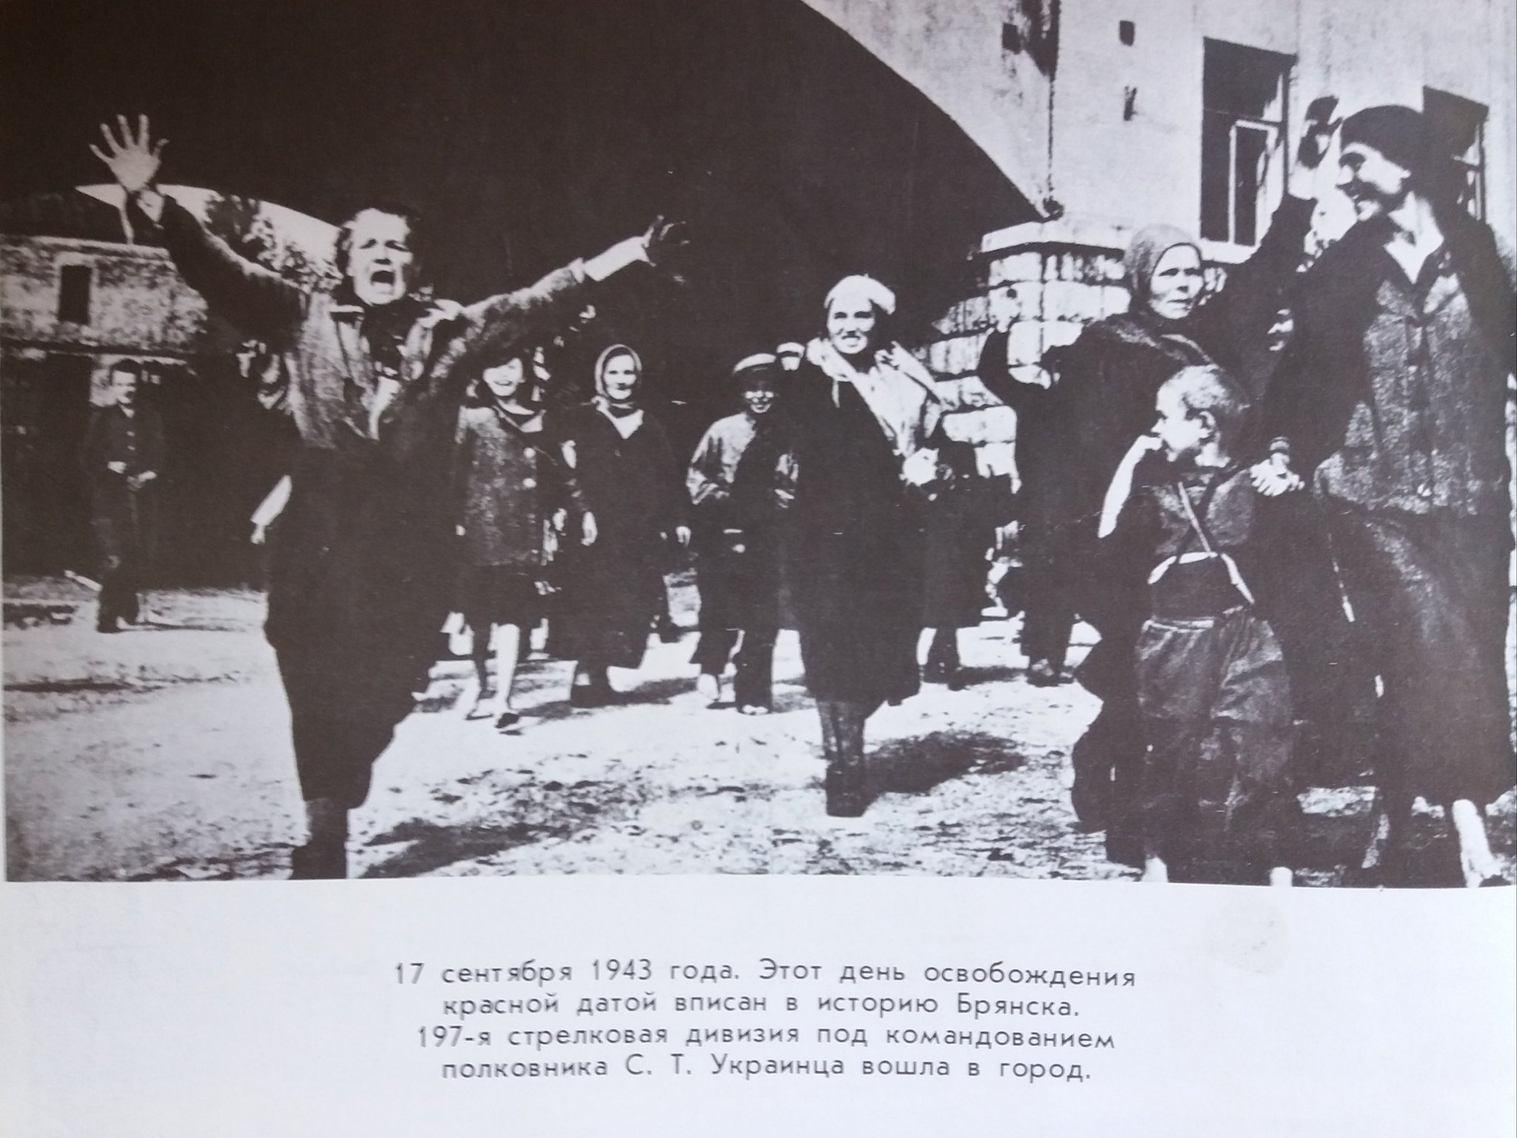

The Soviet partisans were members of a resistance movement which fought a guerrilla war against German occupation of the Soviet Union during World War II.
The movement was coordinated and controlled by the Soviet government and modeled on that of the Red Army. The primary objective of the guerrilla warfare waged by the Soviet partisan units was the disruption of the Eastern Front's German rear, especially road and railroad communications.

By September, 1941 there, in the Bryansk territory, were formed 72 partisan detachments, 91 partisan groups, 330 blasting groups. All who could hold arms joined the partisan detachments. People came in groups, families, settlements.
The partisan groups began mass activities in October - December, 1941. Of great importance for the development of the partisan movement was the Moscow defeat of the German troops in the end of 1941 - the beginning of 1942. The partisans began to liberate settlements driving out Hitler troops.

The German command had to recognize the force of the partisan movement. In his order № 1, issued on February 15,1942, General Wlatsman stated: "According to our intelligence data, there's a good number of partisans. They are well-clad, have good horses, good quantity of skis and camouflage cloaks. In Russian settlements people sympathize with the partisans and help them. 50% per cent of soldiers have to be awake when the troops are supposed to have rest. The posts are set up obligatory where the troops are quartered. Patrolling is organized between the posts".

During January and the first half of February, 1942 the people's resistance movement became general uprising. On February 14, the partisans, supported by the population, liberated from the occupants all Dyatkovo district, including its centre - the town of Dyatkovo. The Soviet power was reestablished in the district and the nearby settlements of other districts. The liberated territory was about 2 500 square kilometers. Thus the first partisan region on the Bryansk soil was formed.
The partisan movement took a full swing in the southern Bryansk districts: Suzemsky, Sevsky, Komarichesky, Vygonichesky and Bryansky. By April, 1942 another big partisan region was formed here, the territory of which was 12 000 square kilometers. More than 500 settlements with the population of more than 200 thousand were liberated. The Soviet power was reestablished here too. Besides this, two partisan zones were formed - Kletnyanskaya and Novozybkovskaya. The territory of those was more than 6 000 square kilometers. About 150 settlements were controlled by the partisans. But the soviet power was not reestablished here.
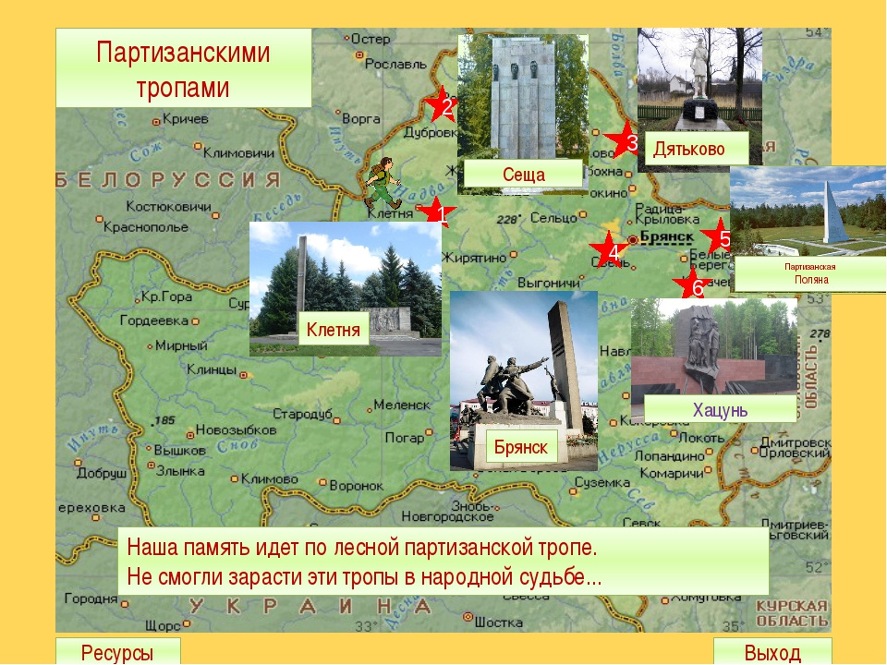
An active part in the underground and partisan struggle against Hitler troops took Komsomol members, showing unprecedented in history heroism. From 80 to 90 per cent of partisan and underground organizers were the Komsomol members and youth. As a rule they were in the most dangerous places. They were machine-gunners, mortar-men, demolition-men, scouts. Many of them were detachments' companies', platoons' commanders etc.

History never knew so mass women participation in the underground and partisan struggle against the enemy. There were 15,8 % per cent of women in the Bryansk partisan detachments. This is the highest level in Russia. They were commanders and commissars of partisan groups, machine-gunners, demolition-women, scouts, medical sisters and nurses. Many underground groups included mainly girls. They worked hard to demoralize enemy soldiers, to gather intelligence data, to supply the partisans with medical stuff. They were given other important tasks. From what was said above one can see that women and girls were on equal terms with men in the struggle against the enemy.

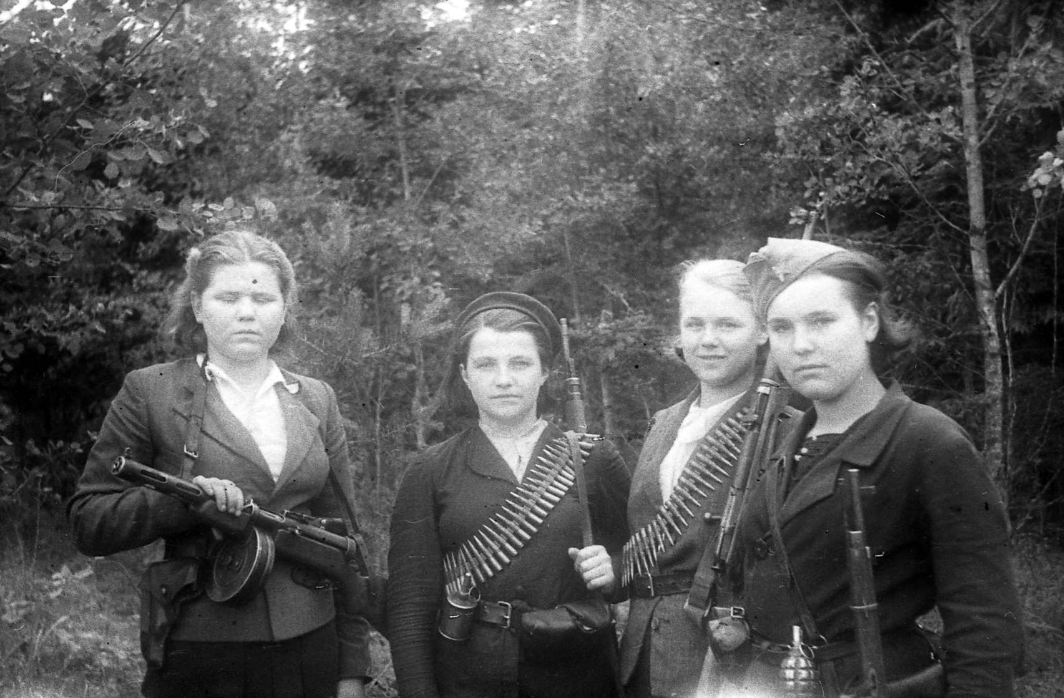

The memorial complex of "Partisan Glade"

"Partsan glade" is a memorial complex, which is located in the Bryansk forests 12 kilometers east of the border city of Bryansk, on the banks of the river Snezhet. The architect of the complex - V.N.Gorodkov. The opening took place in 1969."Partisan meadow" is a traditional venue for official meetings partisans in Russia and CIS countries.This memorial was built on the site where on the eve of the Nazi occupation, in September 1941, was organized by a large collection of Bryansk partisan detachments began their battle your way from that position. Memorial complex "Partisan meadow" was built with the aim to perpetuate the memory of all members of the partisan movement of the Bryansk region.

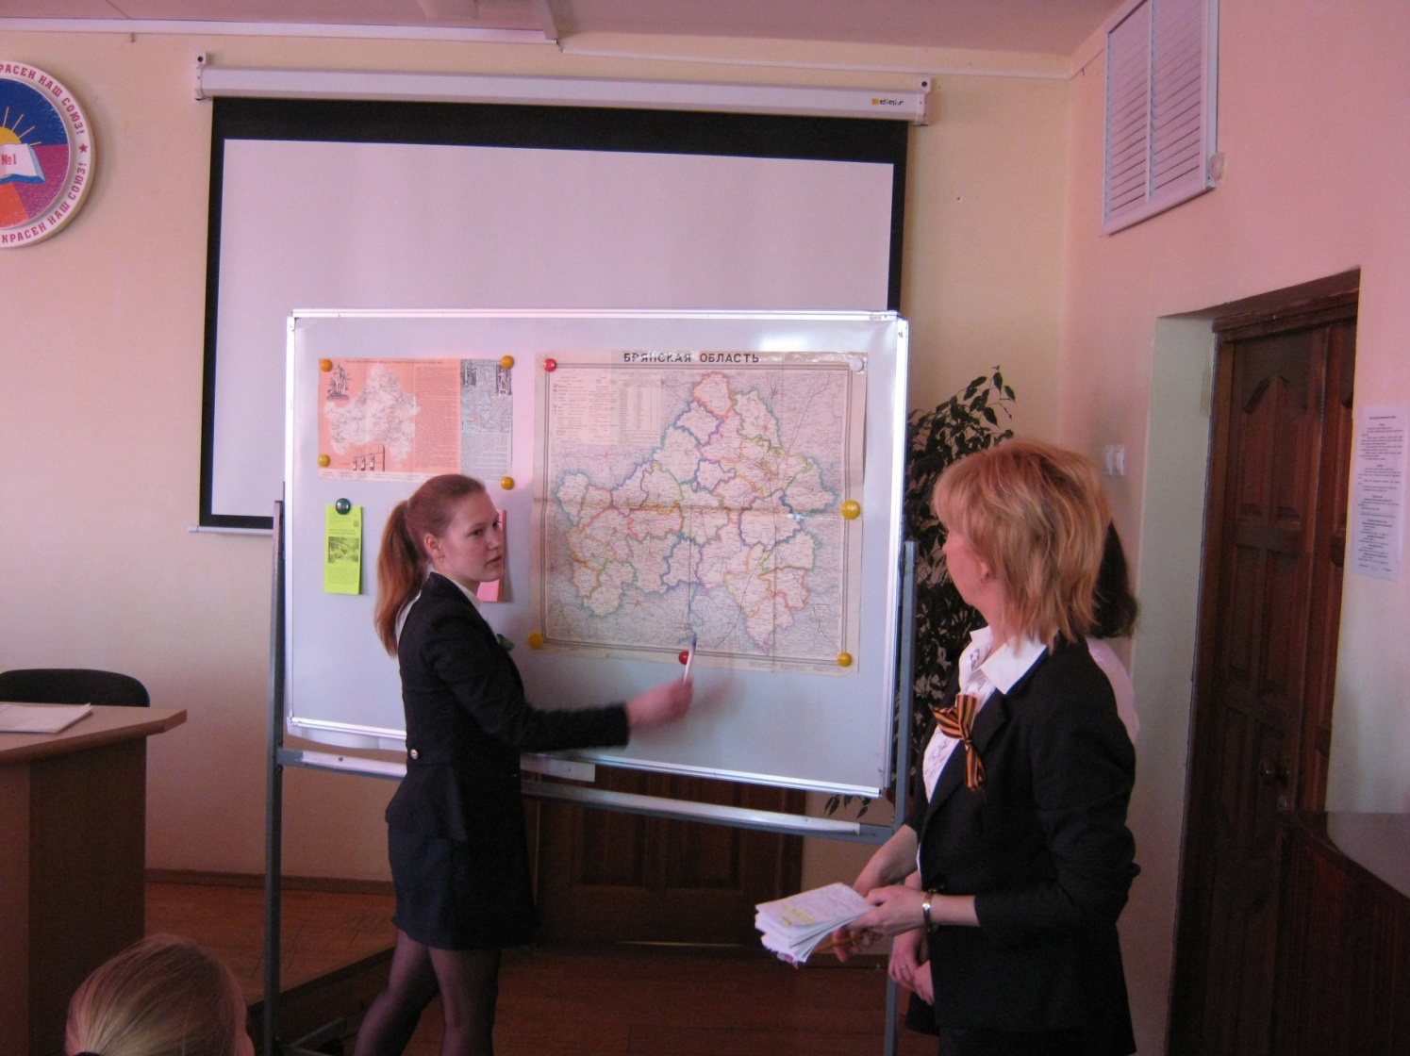

The Soviet partisans were members of a resistance movement which fought a guerrilla war against German occupation of the Soviet Union during World War II.
The movement was coordinated and controlled by the Soviet government and modeled on that of the Red Army. The primary objective of the guerrilla warfare waged by the Soviet partisan units was the disruption of the Eastern Front's German rear, especially road and railroad communications.

During January and the first half of February, 1942 the people's resistance movement became general uprising. On February 14, the partisans, supported by the population, liberated from the occupants all Dyatkovo district, including its centre - the town of Dyatkovo. The Soviet power was reestablished in the district and the nearby settlements of other districts. The liberated territory was about 2 500 square kilometers. Thus the first partisan region on the Bryansk soil was formed.
The partisan movement took a full swing in the southern Bryansk districts: Suzemsky, Sevsky, Komarichesky, Vygonichesky and Bryansky. By April, 1942 another big partisan region was formed here, the territory of which was 12 000 square kilometers. More than 500 settlements with the population of more than 200 thousand were liberated. The Soviet power was reestablished here too. Besides this, two partisan zones were formed - Kletnyanskaya and Novozybkovskaya. The territory of those was more than 6 000 square kilometers. About 150 settlements were controlled by the partisans. But the soviet power was not reestablished here.

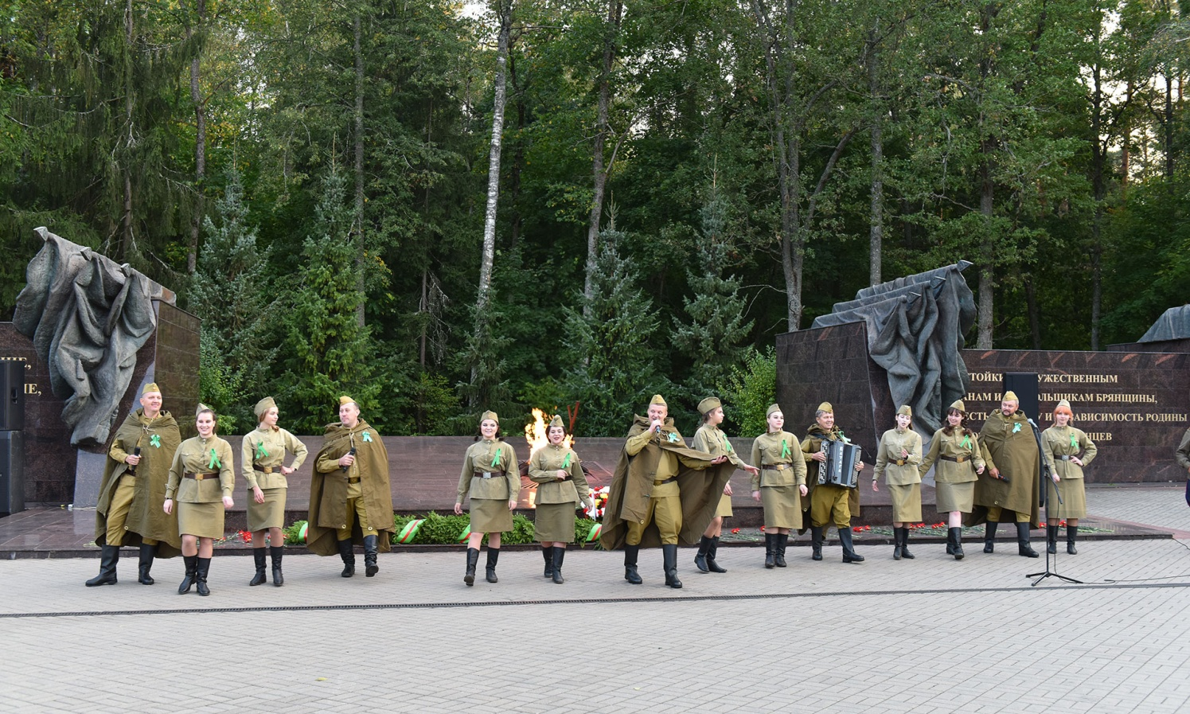

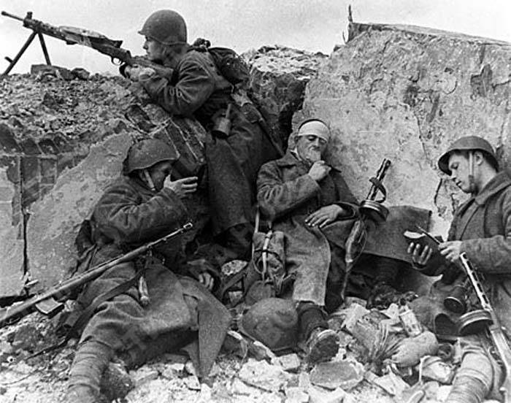

The people of Bryansk fought heroically on the front-lines during the Great Patriotic war. The soldiers of the 331st Bryansk Proletarian division marched fighting from Moscow to Czechoslovakia.
A number of monuments and memorials remind Bryansk people and tourists of the city’s glorious history. There are many monuments symbolizing the feats of Bryansk warriors in the times of the Great Patriotic war. In 1979 Bryansk was awarded the Order of the October Revolution. Ana in 2010 Bryansk has received a rank of a City of Military Glory.
A number of monuments and memorials remind Bryansk people and tourists of the city’s glorious history. There are many monuments symbolizing the feats of Bryansk warriors in during the time of the Great Patriotic war. In 1979 Bryansk was awarded the Order of the October Revolution. And in 2010 Bryansk received the rank of the City of Military Glory.

The photos of the members of the English speaking club LINGUA
